The complete interactive reports and SQL code can be found in the below link.

**https://modeanalytics.com/manikandan_bhaskaran/reports/9bab0752b4e0**

**SQL CASE STUDY**

The Case study is about Yammer which is a social network for communicating with coworkers. Yammer is free to use indefinitely, but companies must pay license fees if they want access to administrative controls, including integration with user management systems like Active Directory.

**More about Yammer:**

Yammer analysts are trained to constantly consider the value of each individual project; they seek to maximize the return on their time. Analysts typically opt for less precise solutions to problems if it means investing substantially less time as well.

They are also taught to consider the impact of everything on the company at large. This includes high-level decision making like choosing which projects to prioritize. It also influences the way analysts think about metrics. Product decisions are always evaluated against core engagement, retention, and growth metrics in addition to product-specific usage metrics (like, for example, the number of times someone views another user’s profile).

**INVESTIGATING A DROP IN USER ENGAGEMENT**

Yammer’s Analysts are responsible for triaging product and business problems as they come up. In many cases, these problems surface through key metric dashboards that execs and managers check daily. You show up to work Tuesday morning, September 2, 2014. The head of the Product team walks over to your desk and asks you what you think about the latest activity on the user engagement dashboards. You fire them up, and something immediately jumps out:

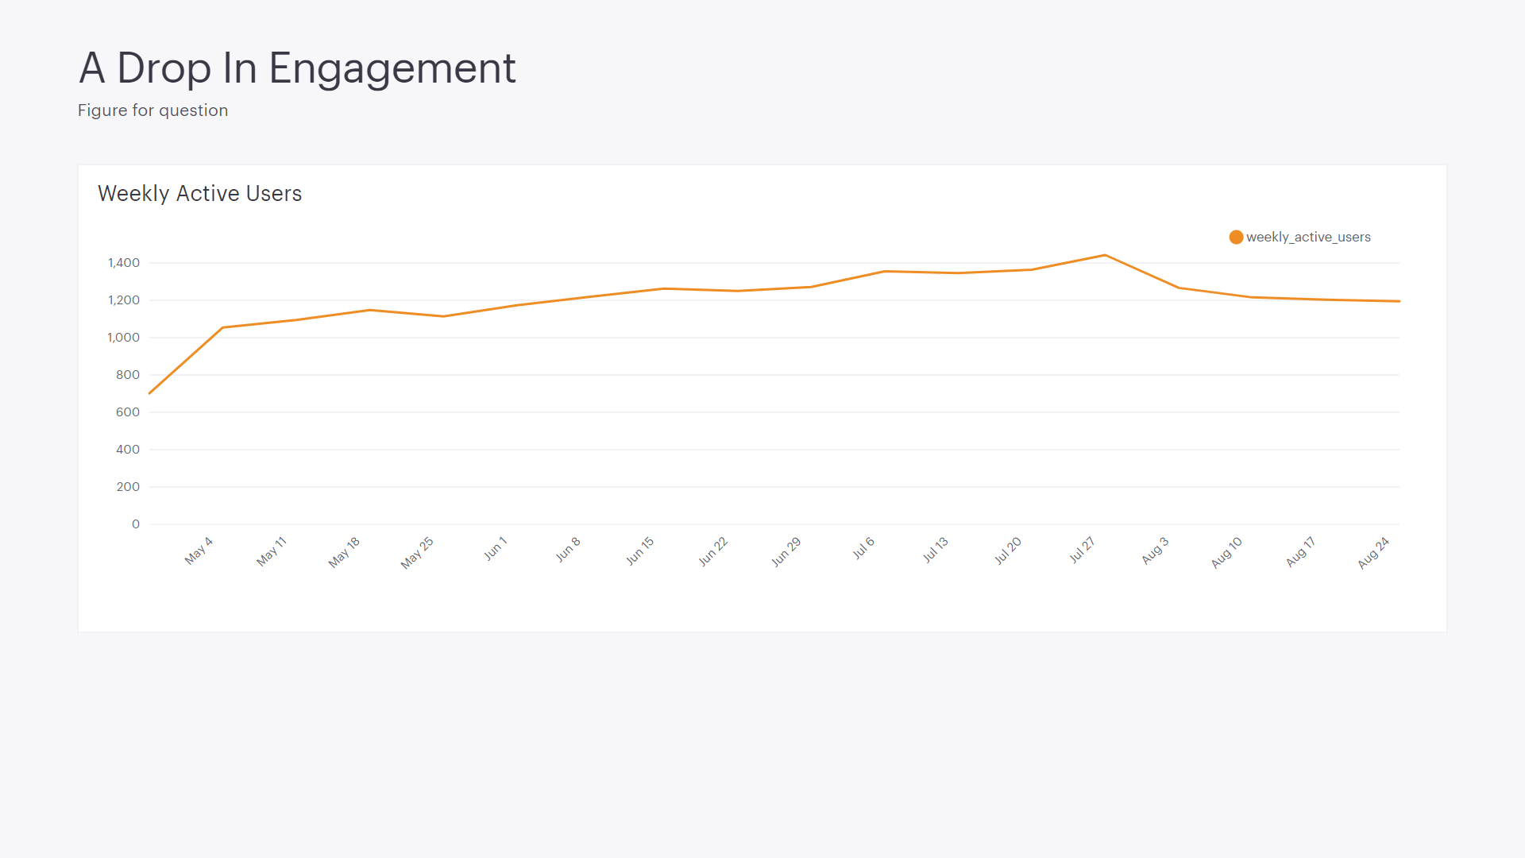

The above chart shows the number of engaged users each week. Yammer defines engagement as having made some type of server call by interacting with the product (shown in the data as events of type “engagement”). Any point in this chart can be interpreted as “the number of users who logged at least one engagement event during the week starting on that date.”

You are responsible for determining what caused the dip at the end of the chart shown above and, if appropriate, recommending solutions for the problem.

**SOLUTION:**

**Before looking at the data:**

**What could be the list of possible causes for the abnormal change in retention?**

1. Sudden dip in the weekly user engagement after august might be due to some Vacation/Holidays
2. This may also be an end in an offer which was already in place like a Marketing Discount
3. It may be also due to a Break in the Code/ Application Downtime or Internet Issues
4. Possibility of Database/Data Error

**COMPLETE ANALYSIS AND SOLUTION:**

**ACTIVATED USERS BY DAY**

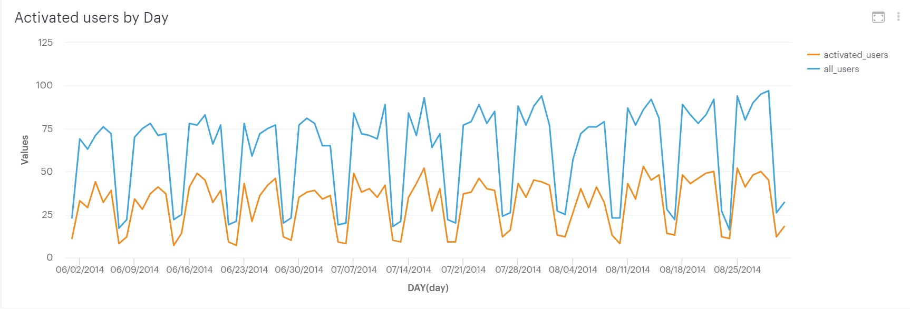

Let’s have a closer look at the activated users by day by and it seems that everything is normal and the users dip during weekends and grow back during the weekdays.

**WEEKLY ACTIVE USERS BY DEVICE**

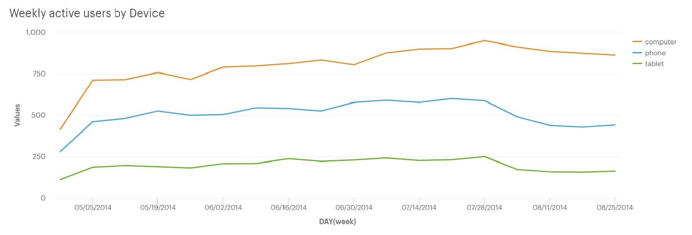

From the chart there is a major decrease in the users using phone and hence investigating the phone users can help with solving the problem.

**WEEKLY EMAIL ENGAGEMENTS**

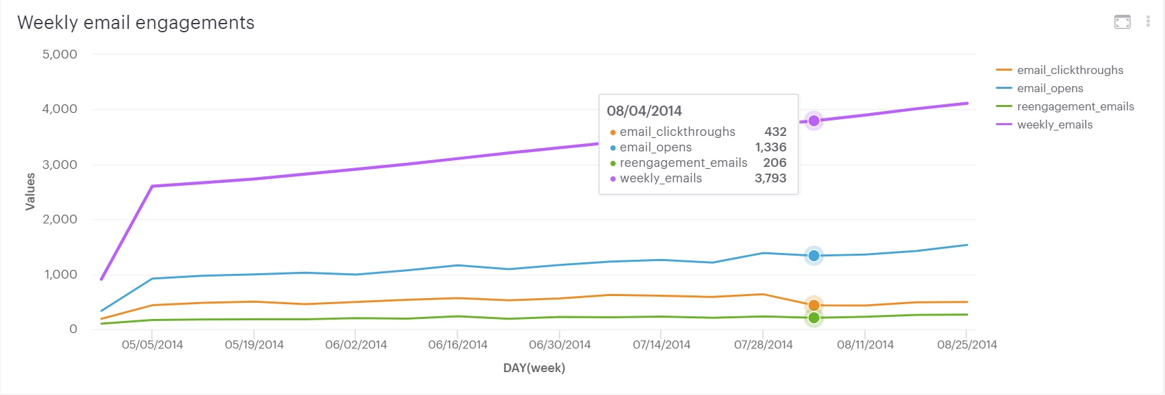

Well, there is another problem with the email engagements as shown in the chart. There is a steep decrease in the email clickthroughs.

**FINAL STEPS**

The investigation is done using the data and the charts made by them and we can declare that the major problem is with the phone and digest emails. Since from the last two charts depicting weekly email activities and activity through devices it is very evident that those are the areas the people should look through. The next steps is to report these activities to the higher management and have them look at your work so that it will save them a lot of time. Though the exact reason for the behavior is not identified, the work can be a tremendous help to save a lot of time.